A
REPORT
ON

Finding Similar Stocks Using Vector Embeddings

BY

Faizan Mohammed – 19STUCHH010017

Project Report submitted to Icfai Tech as a partial
fulfillment of the requirements for the award of the Degree
of B.Tech in Data Science & Artificial Intelligence
under the supervision of Dr. P. Rohini



Faculty of Science & Technology, IFHE University,
Apr 2025

DECLARATION

I declare that the work contained in the Project Report is original and it has been done by me under the supervision of Mrs. P. Rohini. The work has not been submitted to any other University for the award of any degree or diploma.

Date: December 1, 2022

ABSTRACT

In today's highly integrated and globalized world, it's been observed many times that a group of stocks move in tandem with each other, showing almost similar price movements. Stocks belonging to the same sector usually exhibit this phenomenon. But, the relation/similarity between stocks can be beyond just belonging to the same sector. Also, the relationship between stocks can vary over time. In this project, I aim to use vector embeddings created using a deep learning model called Autoencoder to find similar stocks in a certain period of time. The premise is that stocks with similar vector representation (bottleneck of autoencoder) will also be similar and would display similar behavior and characteristics.

Keywords: Stocks, Vector Embeddings, Autoencoder, Time Series

Signature(s) of Student(s) Signature of Faculty
Date: Date:

Table of Contents
1. Introduction 1
1.1 Project Outline 2
1.1.1 Aim of the Project 2
1.1.2 Goals of the Project 2
1.1.3 Creating the Autoencoder Model 2
2. Autoencoder Model 4
2.1 Autoencoder Architecture 4
2.2. Long Short-Term Memory Neural Network (LSTM) 5
2.2.1 Workings of LSTM 5
3. System configuration 6
3.1 Hardware Requirements: 6
3.2 Software requirements 6
4. Literature Review 7
5. Data Preprocessing 8
6. Training the Autoencoder 9
6.1. Gaussian Noise Addition While Training 9
6.2. Orthogonal Regularization 9
6.3 Model Architecture 10
7. Similarity Measures 11
7.1. Cosine Similarity 11
7.2. Euclidian Distance 12
7.3. A Hybrid of Cosine and Euclidian Similarity Measures 13
7.4. Which Similarity Measure is the Best. 14
8. Eigen Portfolio 15
9. Vector Embeddings and Model Output 18
10. Conclusion & Future Scope 19
10.1. Conclusion 19
10.2. Future Scope 19
References 20

Table of Figures

Figure 1 : Process Flow 2
Figure 2: Autoencoder 4
Figure 3 : LSTM cell 5
Figure 4 : Simple Moving Average 8
Figure 5 : Moving Standardization 8
Figure 6 : Gaussian Noise Callback 9
Figure 7 : Orthogonal Regularizatin 9
Figure 8 : Autoencode Model Architecture 10
Figure 9 : Cosine Similarity 11
Figure 10 : Similarity Matrix Heatmap 13
Figure 11 : Returns from different similarity measures 14
Figure 12 : Cumulative Explained Variance 15
Figure 13 : Weights derived from market mode 16
Figure 14 : Stock weights derived from cosine similarity matrix 16
Figure 15 : Stock weights derived from euclidian similarity matrix 17
Figure 16 : Stock weights derived from hybrid similarity matrix 17
Figure 17 : Vector Embedding of SUNPHARMA through time 18
Figure 18 : Real vs Reconstructed 18

1. Introduction

Over the past decades, there has been a significant progress in the fundamental aspects of information technology, which has transformed the course of business. Financial markets, as one of the most fascinating innovations, have a significant impact on the nation's economy. The financial market is a dynamic and complex system in which individuals actively buy and sell currencies, stocks, shares, and derivatives via virtual platforms backed by brokers. The stock market allows investors to purchase shares of publicly traded firms through exchange or over-the-counter trading.

One of the most quintessential indicators by which the health of any economy can be estimated is by observing the state of the stock market of that economy. The financial well-being of most people of most nations is directly or indirectly affected by the fluctuations in the stock market. Modelling stock prices and direction are very important problems in Quantitative Finance.

At any moment is time there are countless factors that affect the price of a stock. All the participants in the market are most probably analyzing every single factor and all publicly available information regarding the company, in order to value the company and figure out the fair price of the stock, given all the available information at that moment in time. Every investor does his own research, has his own biases and comes to maybe different conclusions regarding what the price of a stock should be.

Nobody can say with 100% certainty what the future business growth and profitability of a company can be. So, there is a lot of uncertainty regarding the price of the stock since the future attributes of the company are uncertain. Therefore, uncertainty or stochasticity is inherent to the stock market. Also, there are many stocks in the world, which are inter-connected to each other and may affect one and other. Stocks can be positively correlated or negatively correlated.
This correlation structure in the stock is not stationary, meaning the statistical nature of relation between stocks changes through time.

Many analysts and researchers have developed tools and techniques to forecast stock price movements and find the similarity among stocks and assist investors in making sound decisions. Researchers can use advanced trading algorithms to forecast the market using non-traditional textual data from media. The use of sophisticated machine learning technologies such as text data analytics and ensemble algorithms has significantly improved prediction accuracy. Meanwhile, due to dynamic, inconsistent, and chaotic data, stock market analysis and prediction remain one of the most difficult study topics.

In the recent years, deep learning has transformed many fields. Deep learning has brought much growth and advancement to the fields of Computer Vision (CV) and Natural Language Processing (NLP). In CV, the introduction of Convolutional Neural Networks (CNN) [1] has made deep learning the state of the art for all CV related tasks [2]. Deep learning is also the state of the art approach for NLP [3]. Before the advent of transformer based architecture [4] and BERT [5], long short term memory (LSTM) were mainly used for NLP related tasks.

Autoencoder can be a very powerful and expressive dimensionality reduction method. It’s akin to a non-linear principal component analysis (PCA). In this project I attend to create vector embeddings (latent representation of stock) using autoencoder deep learning model. The most important layer in autoencoder is the bottleneck layer which holds the compressed non-linear latent representation of the input.

1.1 Project Outline

1.1.1 Aim of the Project

In this project, I aim to use vector embeddings created using a deep learning model called Autoencoder to find similar stocks in a certain period of time. The premise is that, stocks with similar vector representation (bottleneck of autoencoder) will also be similar and would display similar behaviour and characteristics. The objective is to use deep learning based approach for measuring similarity/correlation between stock time series data.

1.1.2 Goals of the Project

In this project, I aim to achieve the following goals:
- Create a De-noising autoencoder that is capable of encoding stock time series data to a low-dimensional latent vector space.
- Use the vector representation of stock data to find similar stocks during a specified time frame.
- Experiment with different similarity measure such as Euclidian norm and cosine similarity.

1.1.3 Creating the Autoencoder Model

- The autoencoder tries to recreate the input as perfectly as possible. So, there is the target is input itself. Thus, it’s an unsupervised regression problem.
- It’s a regression problem because prices are usually positive real numbers (continuous).

Figure 1 : Process Flow
- We are using stock data from yahoo finance python library.
- Pre-processing includes taking care of missing values, wrong values and scaling the data (Standardization).
- For creating the autoencoder deep learning model, we will use TensorFlow.
- Once the model is we get the vector representation of all stocks (NIFTY50).
- A similarity measure such as cosine similarity is then used for creation the similarity matrix.

2. Autoencoder Model

2.1 Autoencoder Architecture

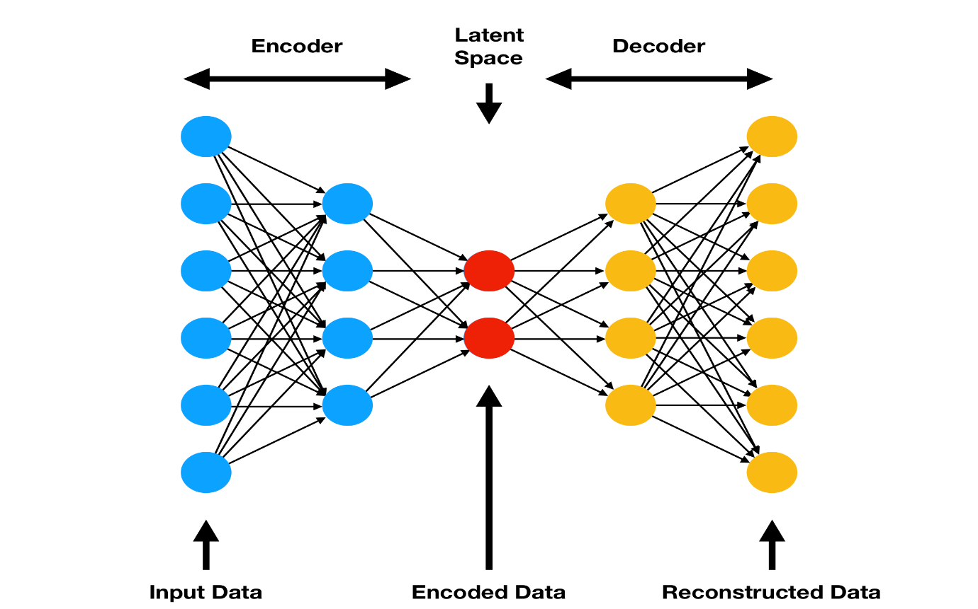

Figure 2: Autoencoder
The autoencoder consist of three parts encoder, bottleneck (Latent Space), decoder. Encoder is the part of the autoencoder which is responsible for compressing the input to a lower dimensional latent representation that holds as much information about the input as possible. Bottleneck layer also called the latent representation layer because this the lower dimensional vector representation of the input. Decoder layer takes latent representation as input and tries to reconstruct the input with as little error as possible.

In our model, we used layers of Long Short Term Memory (LSTM) for both encoder and decoder part of the autoencoder. LSTM are able to capture the temporal nature of the time series stock data.

Steps of Autoencoder Implementation:
1. Using YFinance to collect data of NIFTY50 stocks.
2. Data Preprocessing and wrangling
3. Visualization of Dataset
4. Feature Scaling (Standardization)
5. Preparing the Datasets for training
6. Reshaping the datasets
7. Model Building
8. Usage of dense, LSTM, GRU, Batch-normalizaton and dropout from TensorFlow.
9. Creating the similarity matrix.
10. Result visualization.

2.2. Long Short-Term Memory Neural Network (LSTM)

The long short-term memory network (LSTM) is a type of recurrent neural network (RNN).

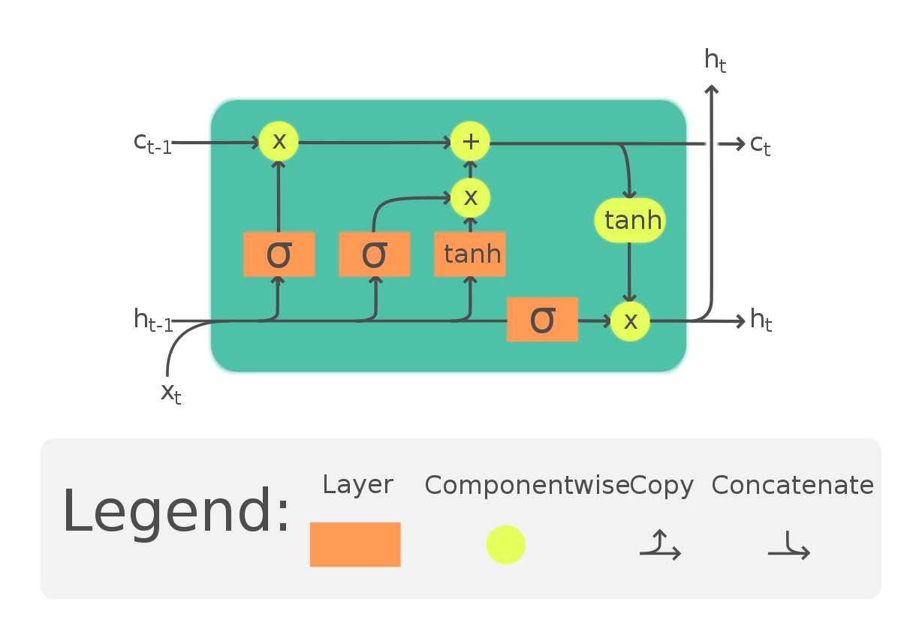
Figure 3 : LSTM cell

2.2.1 Workings of LSTM

LSTM is a network structure that consists of three "gate" components.
An LSTM unit contains three gates: an input gate, a forgetting gate, and an output gate.
Rules can be applied to information as it enters the LSTM network. Only information that adheres to the algorithm will be retained, whereas information that does not conform will be erased via the forgetting gate.

Long Short-term Memory (LSTM) with embedded layer and LSTM neural network with automated encoder are applied.

• To avoid bursting and disappearing gradients, LSTM is utilized instead of RNN.
• Python is used to train the model in this project, while MATLAB is utilized to minimize the dimensions of the input. MySQL is a dataset that is used to store and retrieve data.
• The historical stock data table includes information such as the beginning price, the maximum price, the lowest price, the closing price, the transaction date, the volume, and so on.

3. System configuration

This project can run on commodity hardware. We ran entire project on an Intel I5 processor with 8 GB Ram, 3 GB Nvidia Graphic Processor, It also has 4 cores which runs at 2.2 GHz. First part of the is training phase which takes 5 - 10 mins of time and the second part is testing part which only takes few seconds to make the similarity matrix.

3.1 Hardware Requirements:

• RAM: 8 GB
• Storage: 1 TB
• CPU: 2.2 GHz or faster
• Architecture: 64-bit

3.2 Software requirements

• Python 3.91 in Jupyter Lab is used for data pre-processing, model training.
• Operating System: windows 7

4. Literature Review

In recent years, deep learning (DL) has found application in many fields and has become much popular. The application of machine learning (ML) and DL in the field of finance has been mainly focussed on stock price prediction [6]–[8] and volatility forecasting [9]. There is a lack of research in application of DL to important tasks such portfolio creation and optimization. Effectively figuring out the complex relationships and corelations between varies stocks and other financial instruments that are traded in the financial markets is an essential and a crucial for portfolio construction, optimization and management.

Harry Markowitz in his pioneering work [10] used covariance between returns of stocks as a way for measuring the relationship between stocks and also assessing risk. Even today [10] is the core foundation of the portfolio management techniques that are currently used. Correlation has become the standard way of measuring similarity between time series of financial assets.

This work is inspired by innovations in Natural Language Processing (NLP). NLP has particularly benefitted from advancements in deep learning based, approaches to language modelling. Long Short-Term Memory (LSTM) neural networks [11], transformers [4] and BERT [5] are the deep learning approaches that are currently being used widely for NLP related tasks. One the key innovation in NLP that has significantly contributed to these above mentioned deep learning methods and to the field of NLP is the concept of a vector embedding. Specifically, words are represented numerically by a vector. These vectors are called Word Embeddings in the field of NLP. [12] used time series of stock returns for creating vector embedding,

Word embeddings have been shown to be capable of numerically capturing the essence of the word it’s representing and can even capture the semantic relation between two words. For example, the vector representation of the word “Airplane” and “Aircraft” would be very similar and would reside close to each other in the embedding space. The two most popular methods of creating word embeddings is GloVe [13] and Word2Vec [14]. Embeddings are heavily used in NLP for representing language data in NLP. The application of embeddings in the financial domain have, for the most part, been limited to the NLP idea of word embeddings. Word embeddings have been in financial ML for the purpose of sentiment analysis of stock related news. Then the extracted sentiment information is fed the main forecasting model as a feature [15].

Vector embeddings can also be used for handling categorical data. Rather than using one-hot encoding, which is sparse and inefficient, we can use entity embedding for numerically representing the categorical features in data [16].

De-autoencoders [17] are neural networks that are capable of compressing high-dimensional input data into a condensed lower dimensional space. The lower dimensional representation of the input can be thought of as an vector embedding of the input with only essential information, that is required by the decoder for reconstruction of the input. The autoencoder is a non-linear transformation, contrary to principal component analysis (PCA), which makes the autoencoder more flexible and powerful [18]. Autoencoder can also be used for the purpose of dimensionality reduction [19].

5. Data Preprocessing

For standardizing the time series data we used the moving average and similarly moving standard deviation. The window size selected is 10 days.

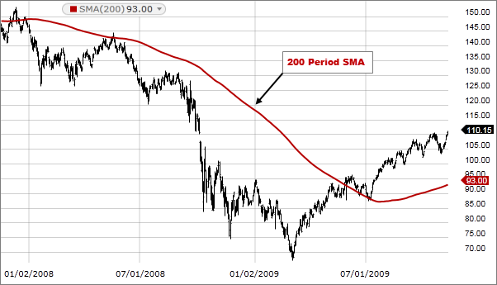

Figure 4 : Simple Moving Average
The longer the window size the less reactive the moving average is to the current market state and if the window size is small then the moving average fluctuates too much.

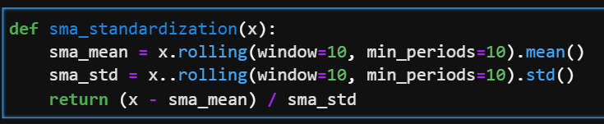

Figure 5 : Moving Standardization

6. Training the Autoencoder

The model consists of three parts. The encoder, decoder and the bottleneck. All three components make use of LSTM layers for capturing the temporal nature of the data. We make use of BatchNormalization layers fot taking care of internal data drift and also for regularizing the model. Dropout layers are also used at varies places in the model to avoid overfitting and also to encourage the model to learn new pathways for compressing the input data.

The model is fairly small with approximately 3300 parameters. For optimizer, Adam[20] with a small learning rate of 0.0003 was used. Small ensures that the model converges as close the global minima as possible.

6.1. Gaussian Noise Addition While Training

Gaussian noise with relatively small standard deviation is added to the input for encouraging the model to generalize and also as tool to avoid overfitting. Financial time series data has a very low signal to noise ratio, so adding noise also makes sure the same data is never seen by the model, which helps in out of sample performance.

The mean or centre of the gaussian from which noise is sampled is constant at zero, But at the beginning of every epoch the standard deviation is sampled from an uniform distribution spreading between 0.005 and 0.015.

Addition of gaussian noise makes the job of the encoder not only to compress the input to a lower dimensional latent space, but also to remove noise from the input data. We use a custom TensorFlow callback for sampling and changing the standard deviation of the noise gaussian during training.

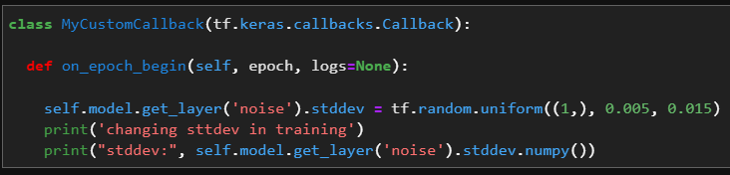

Figure 6 : Gaussian Noise Callback

6.2. Orthogonal Regularization

Orthogonal regularizer encourages vectors to be orthogonal to each other. Being orthogonal means the correlation between vectors is zero, in other words they are independent of each other and capture unique things about the data and aren’t affected by same factors.
We specifically use L2 orthogonal regularizer.
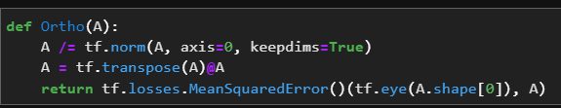

Figure 7 : Orthogonal Regularizatin

6.3 Model Architecture

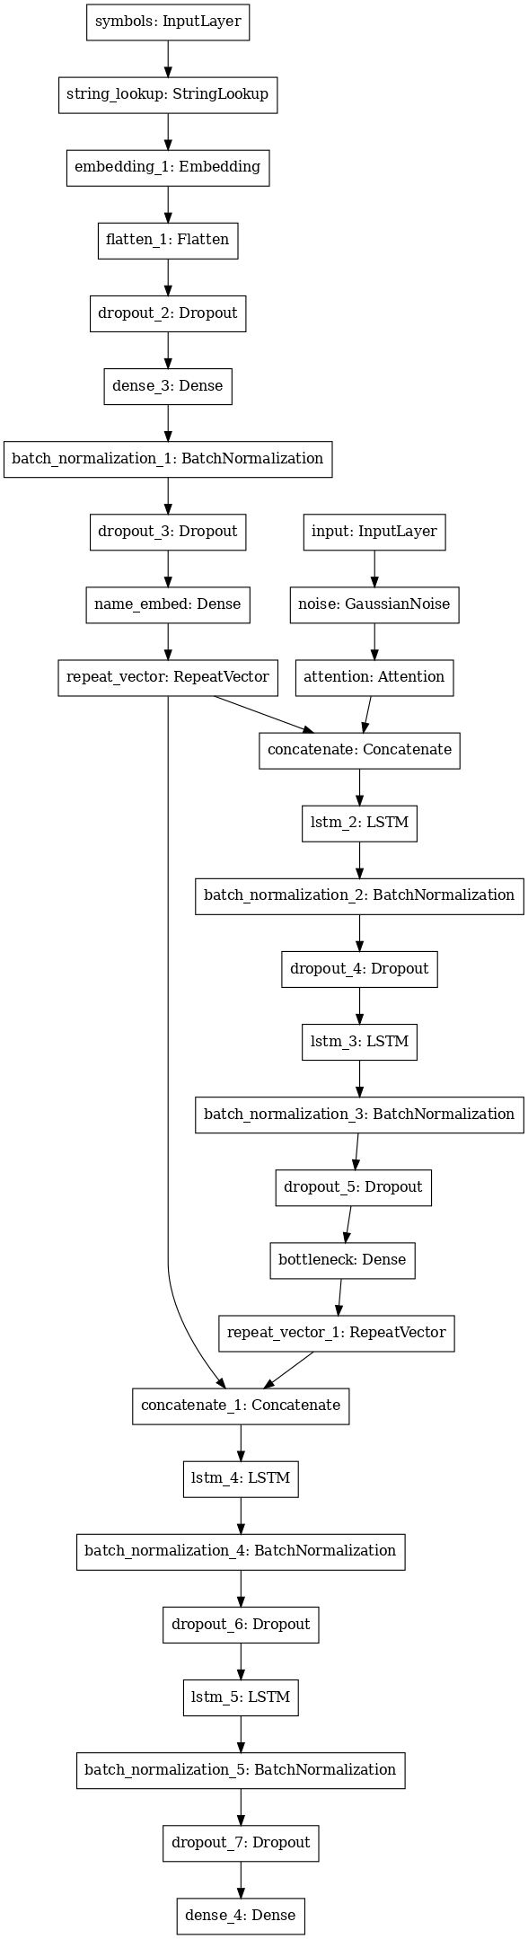
Figure 8 : Autoencoder Model Architecture

7. Similarity Measures

The similarity measure is the measure of how much alike two data objects are. A similarity measure is a data mining or machine learning context is a distance with dimensions representing features of the objects. If the distance is small, the features are having a high degree of similarity. Whereas a large distance will be a low degree of similarity.

The similarity measures used here are as follows:

- Cosine Similarity
- Euclidian Distance.
- A Hybrid of Cosine and Euclidian Similarity Measures.

7.1. Cosine Similarity

The cosine similarity metric finds the normalized dot product of the two attributes. By determining the cosine similarity, we would effectively try to find the cosine of the angle between the two objects. The cosine of 0° is 1, and it is less than 1 for any other angle.

It is thus a judgment of orientation and not magnitude. Two vectors with the same orientation have a cosine similarity of 1, two vectors at 90° have a similarity of 0. Whereas two vectors diametrically opposed having a similarity of -1, independent of their magnitude.

The cosine similarity always belongs to the interval [-1,1]. For example, two proportional vectors have a cosine similarity of 1, two orthogonal vectors have a similarity of 0, and two opposite vectors have a similarity of -1.
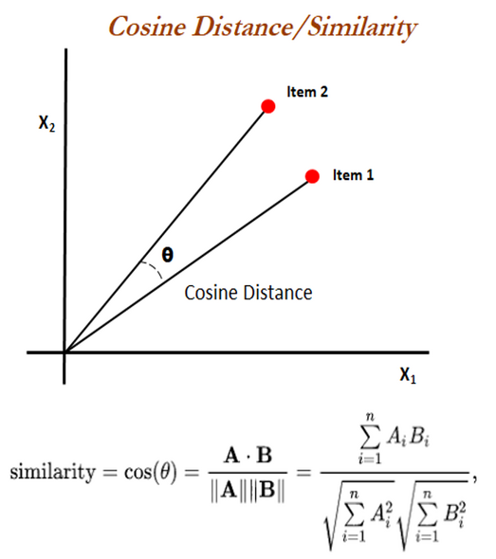

Figure 9 : Cosine Similarity

7.2. Euclidian Distance

Euclidean distance is the most common use of distance measure. In most cases when people say about distance, they will refer to Euclidean distance. Euclidean distance is also known as simply distance. When data is dense or continuous, this is the best proximity measure. The Euclidean distance between two points is the length of the path connecting them. The Pythagorean theorem gives this distance between two points.

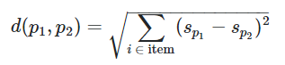

Euclidian distance is zero for similar vector and positive for non-similar vectors. It belongs to the interval [0, +infinity]. But, we want it be bounded and similar vectors should yield output of 1 and 0 if the vectors not similar. So, we add one to the Euclidian distance and then invert it. Now the output belongs to the interval [0, 1], as we wanted.

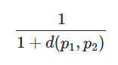

7.3. A Hybrid of Cosine and Euclidian Similarity Measures

Cosine similarity does not take into account the magnitude the vectors, it only measures the cosine of the angel between them. Which means all available information is not utilised. On the other hand Euclidian distance only measures the distance between two vectors and does not take into account the orientation of those vectors.

Thus, we combined the two similarity measures that only take into consideration one aspect of the vectors, in-order to create a measure that takes both of them into consideration.

The hybrid is nothing but the product of cosine similarity and Euclidian similarity.

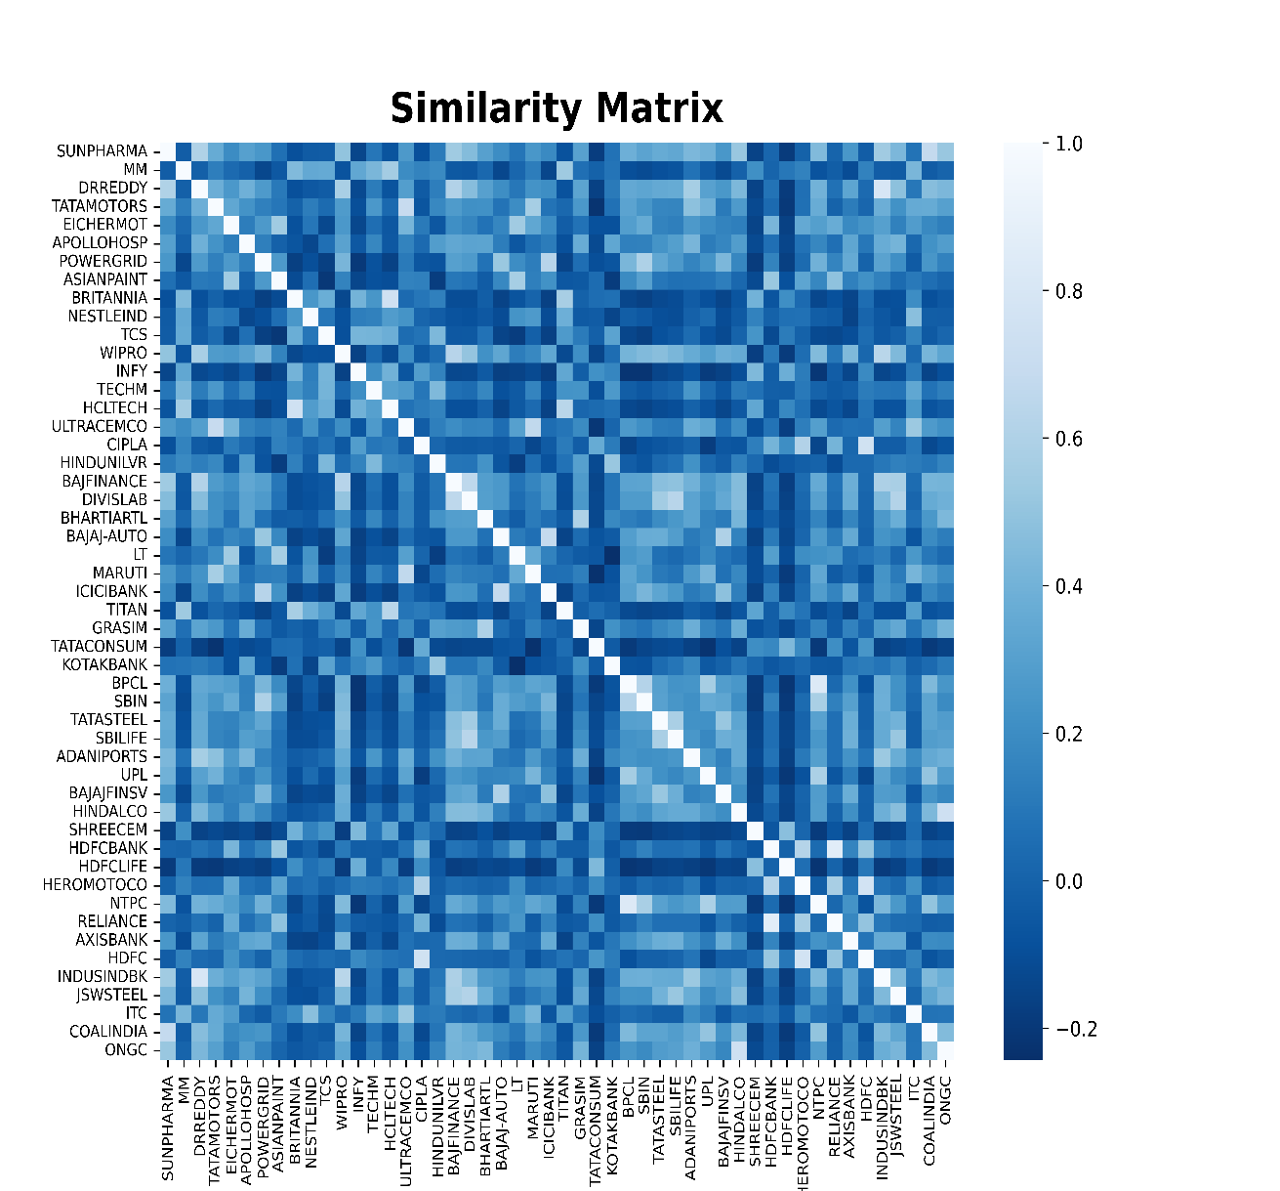

Figure 10 : Similarity Matrix Heatmap

7.4. Which Similarity Measure is the Best.

We create eigen portfolios from the different similarity matrices received from using different similarity measures in order to ascertain which similarity measure is the best.

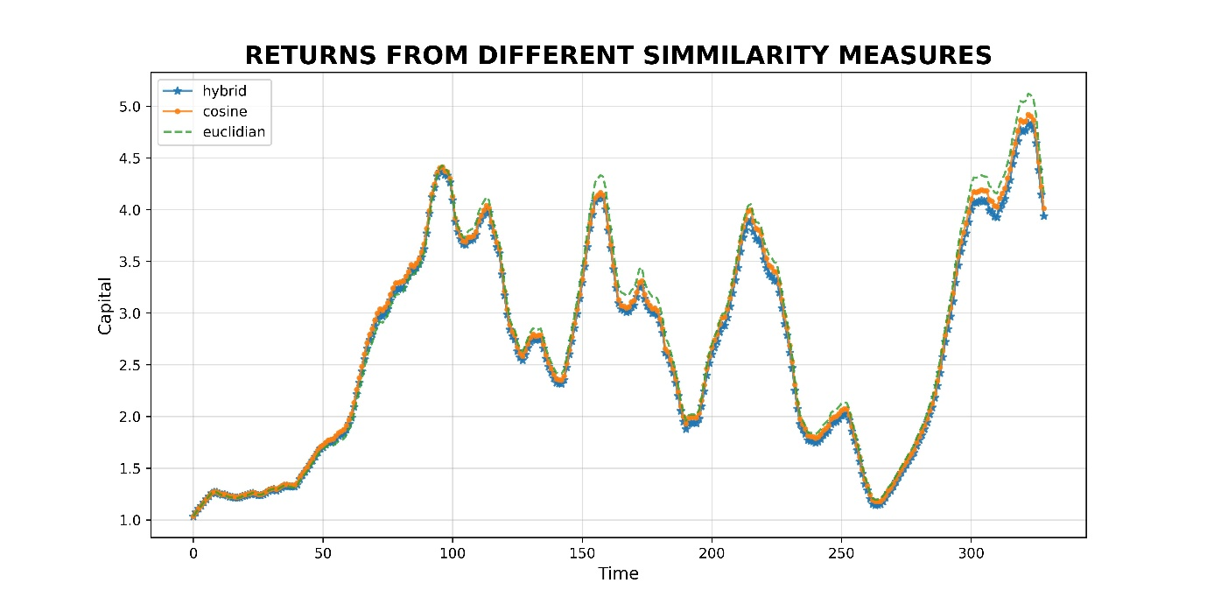

Figure 11 : Returns from different similarity measures

As it is visible the all three similarity measures are not significantly different from each other and are highly positively correlated.

8. Eigen Portfolio

For those familiar with Principal Component Analysis, some of this next section will look familiar. In fact, since the covariance matrix is similar by definition to the correlation matrix (in the sense of a linear transformation similarity), the eigenvalues will be the same and the eigenvectors (which we are interested in) have a 1-1 correspondence between them, assuming none of the variances for any of the stocks are equal to 0.

The covariance matrix has some nice properties in the case of stock returns. First of all, it is a symmetric matrix, and so its eigenvalues are positive and its eigenvectors are orthogonal to each other. The typical interpretation of the eigenvalue decomposition of a covariance matrix is this:

The eigenvalues give the “variance” of each “factor” or eigenvector. The variance associated with each factor is “uncovariated” with the others (If we use the correlation matrix, this would be uncorrelated.)

I put the words above in quotes because this is meaningless until you connect it to where the matrix came from. Here, we know loosely that each eigenvalue corresponds to the risk of a portfolio and that the eigenvectors can represent an allocation of weights. So in this context, we can make the interpretations

- Eigenvectors are the “eigen portfolios”, strategy weight allocations which are uncorrelated to other eigen-portfolios
- Eigenvalues are the “risk” of the given eigen-portfolio

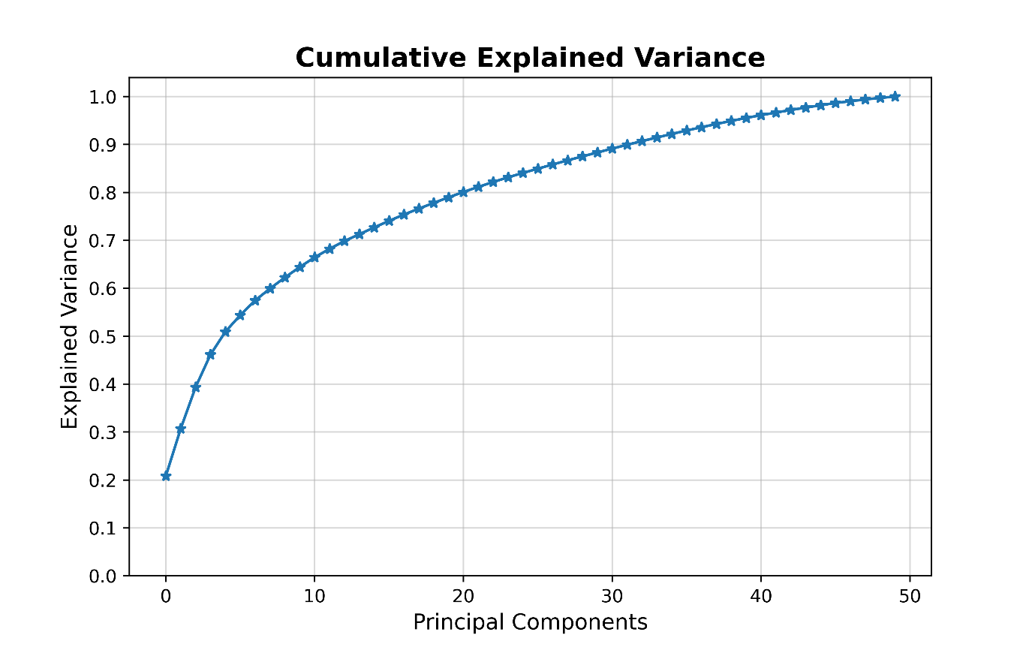
Figure 12 : Cumulative Explained Variance
The eigen vector associated with the highest eigen value is called the market mode. It capture the most important economic factors, such as inflation, interest rates, currency exchange rate and other essential macro-economic factors, that affect every capitalistic activity on a wide scale.

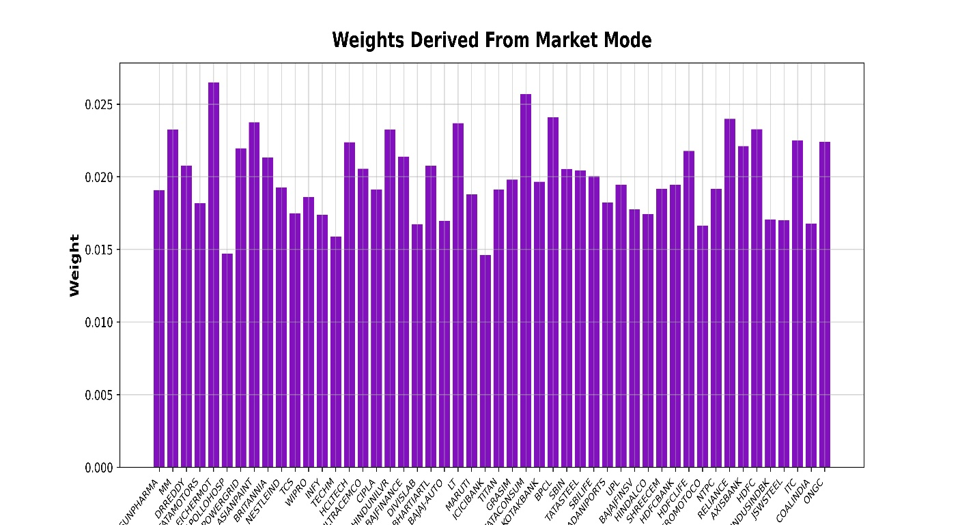

Figure 13 : Weights derived from market mode

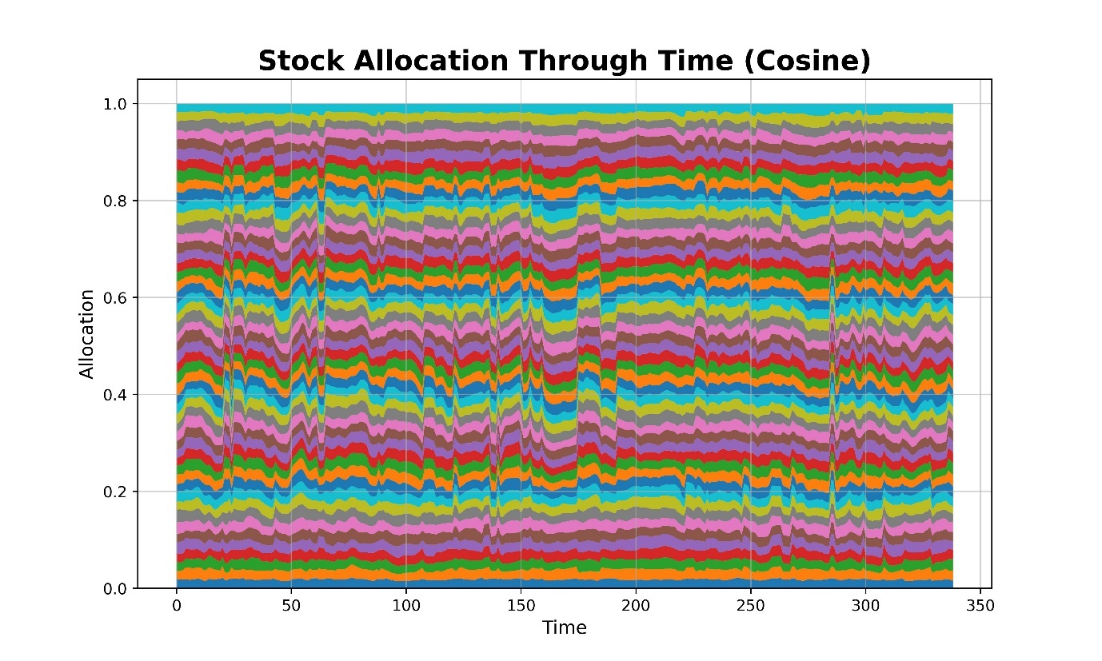
Figure 14 : Stock weights derived from cosine similarity matrix

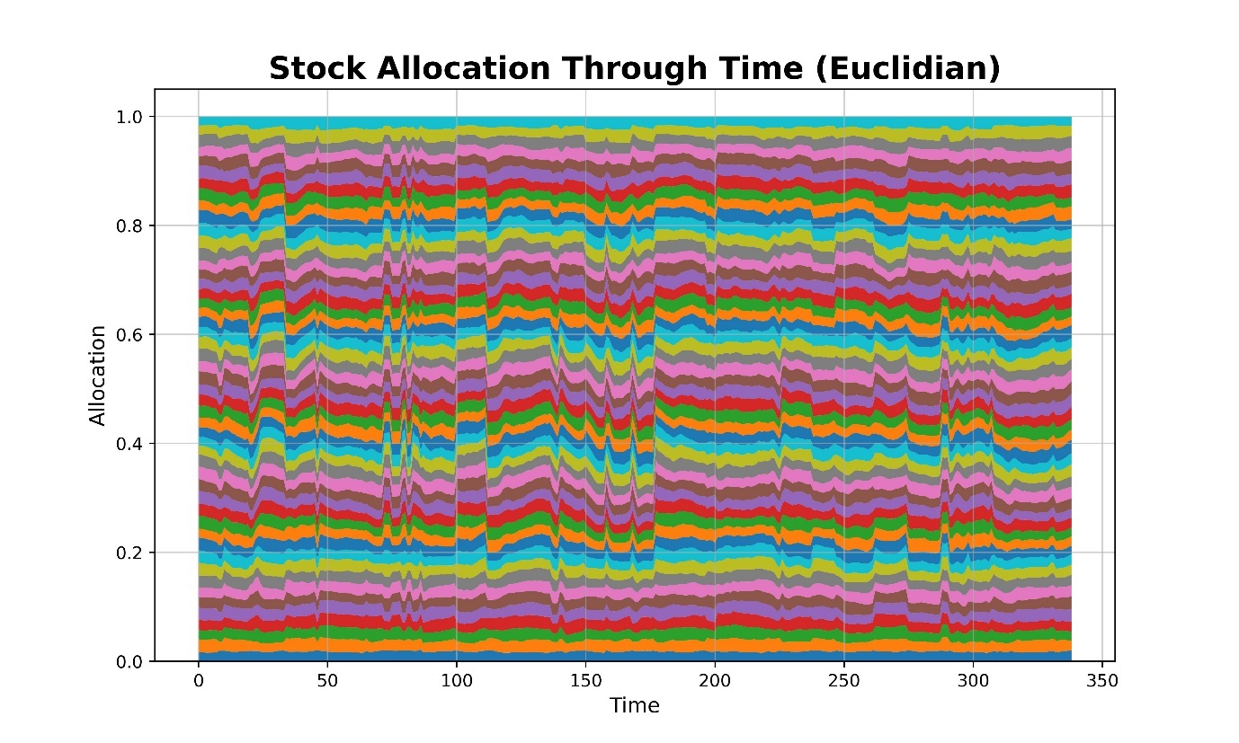
Figure 15 : Stock weights derived from euclidian similarity matrix
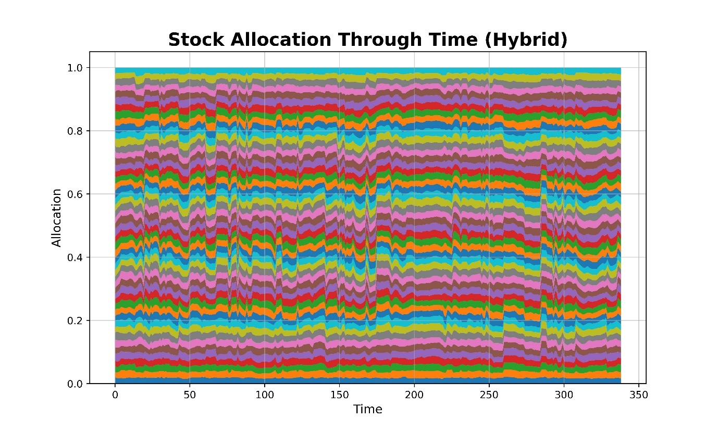

Figure 16 : Stock weights derived from hybrid similarity matrix

9. Vector Embeddings and Model Output

The trained Autoencoder model has a four dimensional bottleneck. Which means input is compressed to be represented by a four dimensional vector and we use orthogonal regularlizer to make sure that each dimension captures as much distinct information about the input as possible.

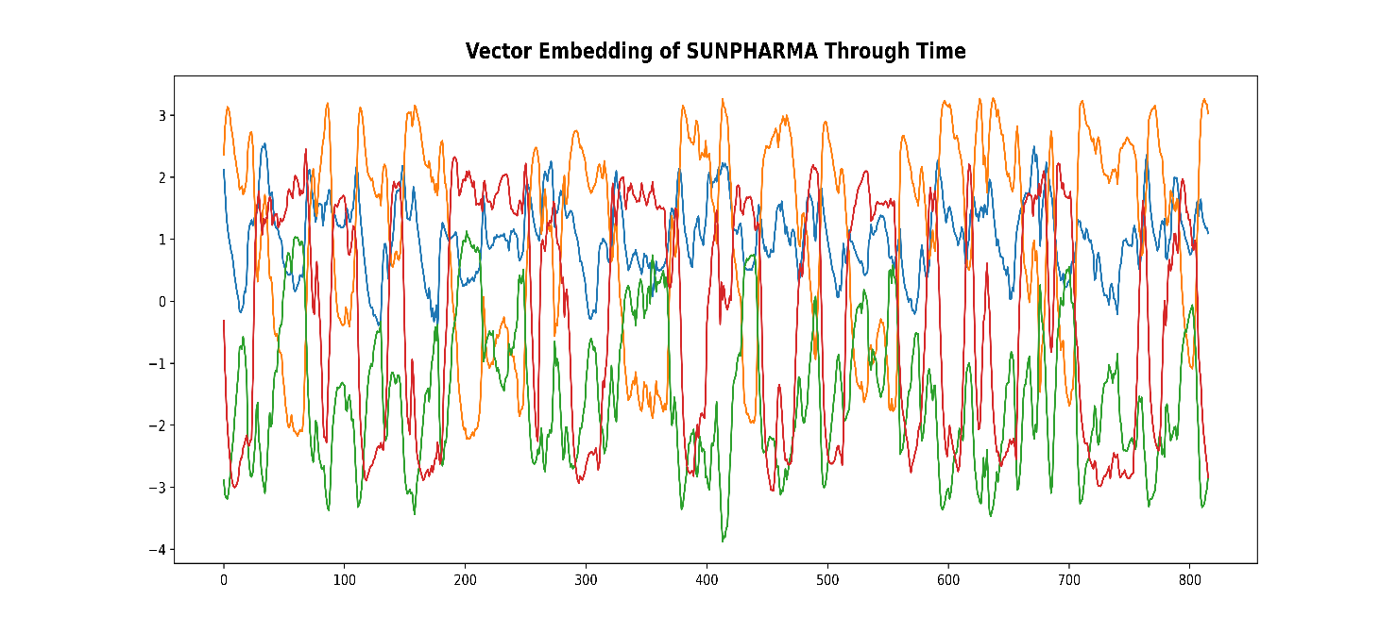
Figure 17 : Vector Embedding of SUNPHARMA through time

The reconstructed input is very smooth and captures the trend and seasonality in the data.

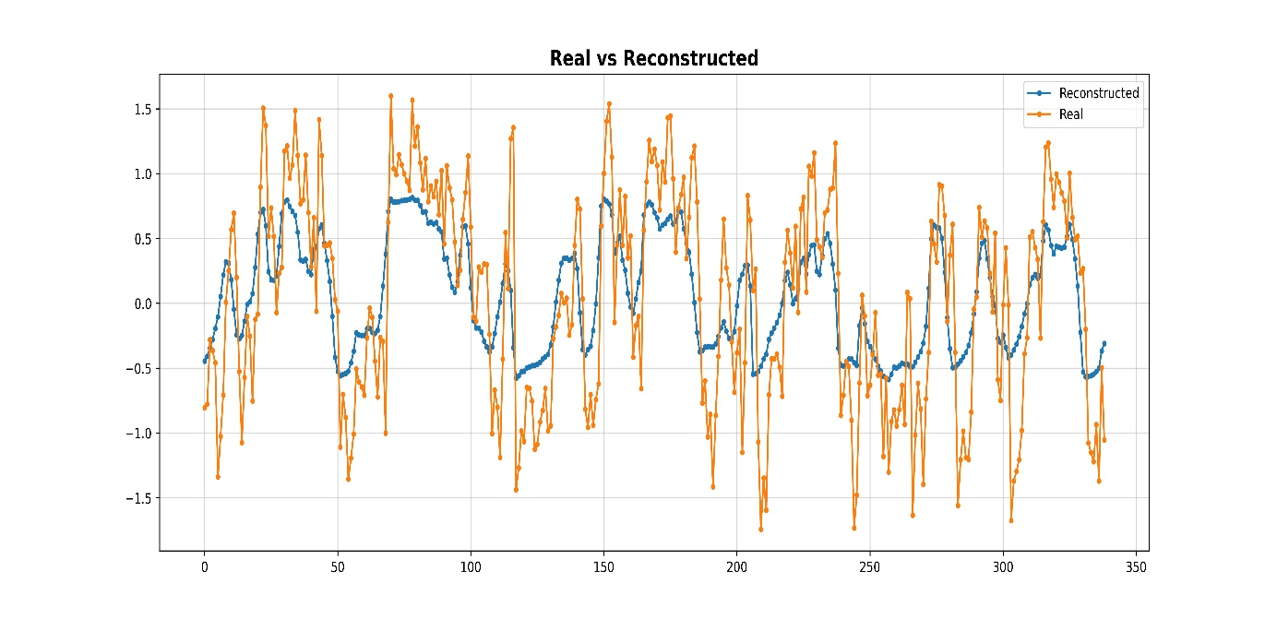

Figure 18 : Real vs Reconstructed

10. Conclusion & Future Scope

10.1. Conclusion

We have found that Autoencoder deep learning model can be effectively applied for compression high dimensional heteroscedastic time series data, such as stock market data. The Autoencoder trained here was able to successfully compress the input stock price time series to a four dimensional latent space. We have also used different similarity measures for constructing the similarity matrix from the obtained vector embeddings from the trained autoencoder. We ascertained that there is no significant difference between the any of the used similarity measures, I think it because all three similarity measures are mathematically closely related.

10.2. Future Scope

The future direction for further work, in order to improve the model can be as follows,

- Using some other probability distribution other than Gaussian as noise.
- Experiment with different bottleneck sizes.
- Incorporate Multi-head attention for more robust model and better context modelling.

References

[1] Y. Lecun, L. Bottou, Y. Bengio, and P. Haffner, “Gradient-based learning applied to document recognition,” Proceedings of the IEEE, vol. 86, no. 11, pp. 2278–2324, 1998, doi: 10.1109/5.726791.
[2] S. S. A. Zaidi, M. S. Ansari, A. Aslam, N. Kanwal, M. N. Asghar, and B. Lee, “A Survey of Modern Deep Learning based Object Detection Models,” CoRR, vol. abs/2104.11892, 2021, [Online]. Available: https://arxiv.org/abs/2104.11892
[3] A. Torfi, R. A. Shirvani, Y. Keneshloo, N. Tavaf, and E. A. Fox, “Natural Language Processing Advancements By Deep Learning: A Survey,” CoRR, vol. abs/2003.01200, 2020, [Online]. Available: https://arxiv.org/abs/2003.01200
[4] A. Vaswani et al., “Attention Is All You Need,” CoRR, vol. abs/1706.03762, 2017, [Online]. Available: http://arxiv.org/abs/1706.03762
[5] J. Devlin, M.-W. Chang, K. Lee, and K. Toutanova, “BERT: Pre-training of Deep Bidirectional Transformers for Language Understanding,” CoRR, vol. abs/1810.04805, 2018, [Online]. Available: http://arxiv.org/abs/1810.04805
[6] S. Mehtab and J. Sen, “Stock price prediction using CNN and LSTM-based deep learning models,” in 2020 International Conference on Decision Aid Sciences and Application (DASA), 2020, pp. 447–453.
[7] P. Ghosh, A. Neufeld, and J. K. Sahoo, “Forecasting directional movements of stock prices for intraday trading using LSTM and random forests,” CoRR, vol. abs/2004.10178, 2020, [Online]. Available: https://arxiv.org/abs/2004.10178
[8] F. Kamalov, L. Smail, and I. Gurrib, “Stock price forecast with deep learning,” in 2020 International Conference on Decision Aid Sciences and Application (DASA), 2020, pp. 1098–1102.
[9] S. Liao, J. Chen, and H. Ni, “Forex Trading Volatility Prediction using NeuralNetwork Models,” arXiv preprint arXiv:2112.01166, 2021.
[10] H. Markowitz, “Portfolio Selection,” J Finance, vol. 7, no. 1, pp. 77–91, 1952, doi: 10.2307/2975974.
[11] S. Hochreiter and J. Schmidhuber, “Long Short-term Memory,” Neural Comput, vol. 9, pp. 1735–1780, Dec. 1997, doi: 10.1162/neco.1997.9.8.1735.
[12] R. Dolphin, B. Smyth, and R. Dong, “Stock Embeddings: Learning Distributed Representations for Financial Assets,” arXiv preprint arXiv:2202.08968, 2022.
[13] J. Pennington, R. Socher, and C. Manning, “GloVe: Global Vectors for Word Representation,” in Proceedings of the 2014 Conference on Empirical Methods in Natural Language Processing (EMNLP), Oct. 2014, pp. 1532–1543. doi: 10.3115/v1/D14-1162.
[14] T. Mikolov, K. Chen, G. s Corrado, and J. Dean, “Efficient Estimation of Word Representations in Vector Space,” Proceedings of Workshop at ICLR, vol. 2013, Jan. 2013.
[15] E. Rahimikia, S. Zohren, and S.-H. Poon, “Realised Volatility Forecasting: Machine Learning via Financial Word Embedding,” arXiv preprint arXiv:2108.00480, 2021.
[16] C. Guo and F. Berkhahn, “Entity Embeddings of Categorical Variables,” CoRR, vol. abs/1604.06737, 2016, [Online]. Available: http://arxiv.org/abs/1604.06737
[17] Y. Bengio, L. Yao, G. Alain, and P. Vincent, “Generalized Denoising Auto-Encoders as Generative Models,” CoRR, vol. abs/1305.6663, 2013, [Online]. Available: http://arxiv.org/abs/1305.6663
[18] S. Ladjal, A. Newson, and C.-H. Pham, “A PCA-like Autoencoder,” CoRR, vol. abs/1904.01277, 2019, [Online]. Available: http://arxiv.org/abs/1904.01277
[19] Q. Fournier and D. Aloise, “Empirical comparison between autoencoders and traditional dimensionality reduction methods,” CoRR, vol. abs/2103.04874, 2021, [Online]. Available: https://arxiv.org/abs/2103.04874
[20] D. P. Kingma and J. Ba, “Adam: A method for stochastic optimization,” arXiv preprint arXiv:1412.6980, 2014.

